| Course Name | ITD 2343 – Object Oriented Programming with C# |
| --- | --- |
| Instructor | Mark L. Pranger |
| Student Name | <Ezequiel Barrientos> |
| Due date | <11/23/25> |
| Grade | <grade earned here> |
| Grading Comments | <instructor comments here> |

Test 1: Ezequiel Barrientos Plain to Cipher

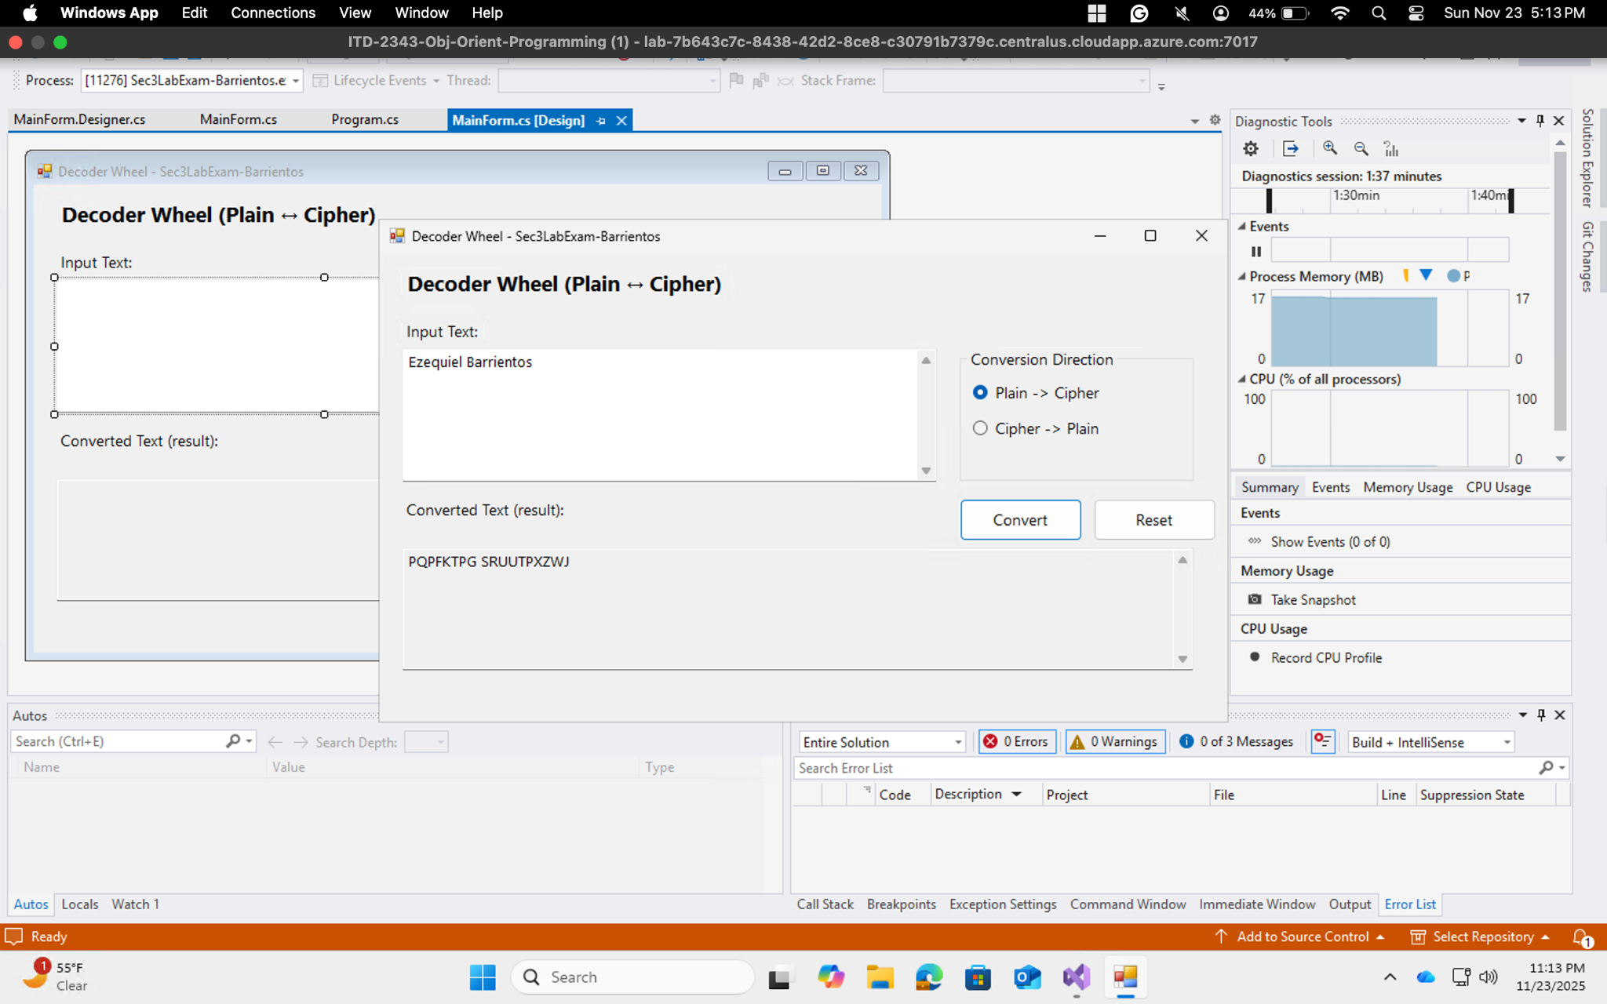

Test 2 Professor Mark Pranger Plain to Cipher

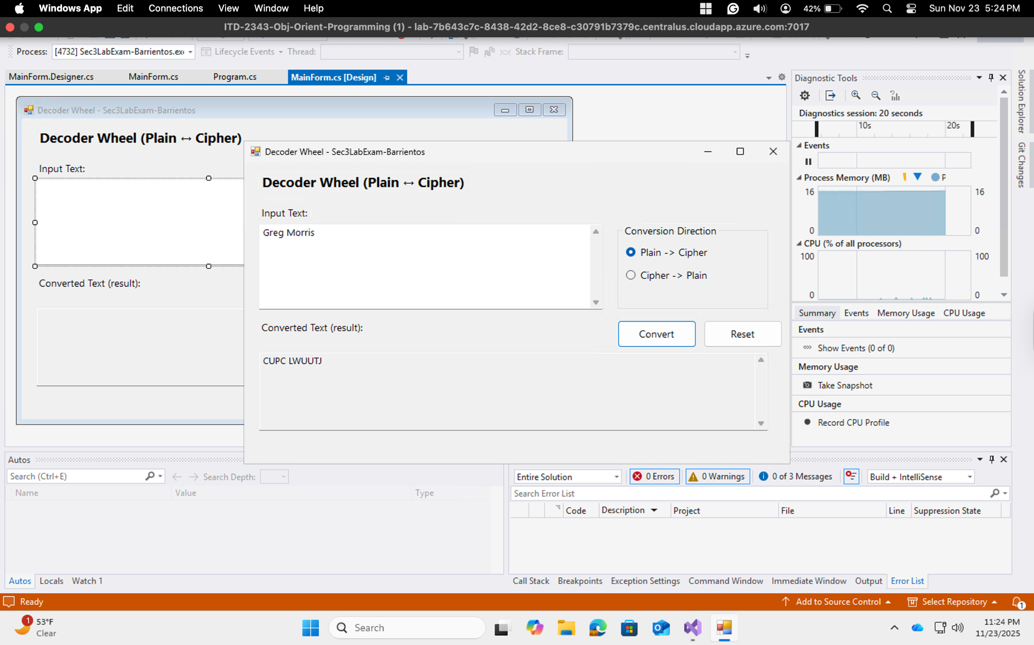

Test 3 Four Score and Seven Years Ago Plain to Cipher

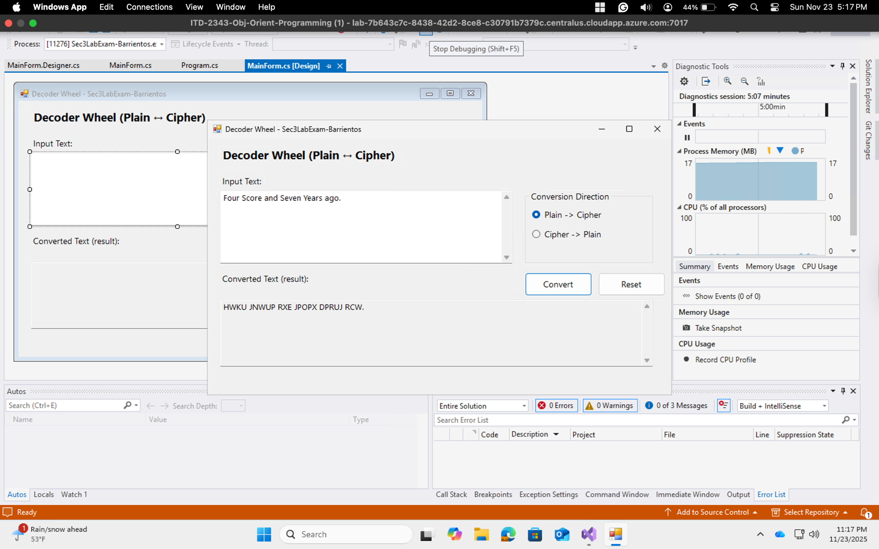

Test 4 Ezequiel Barrientos Cipher to Plain

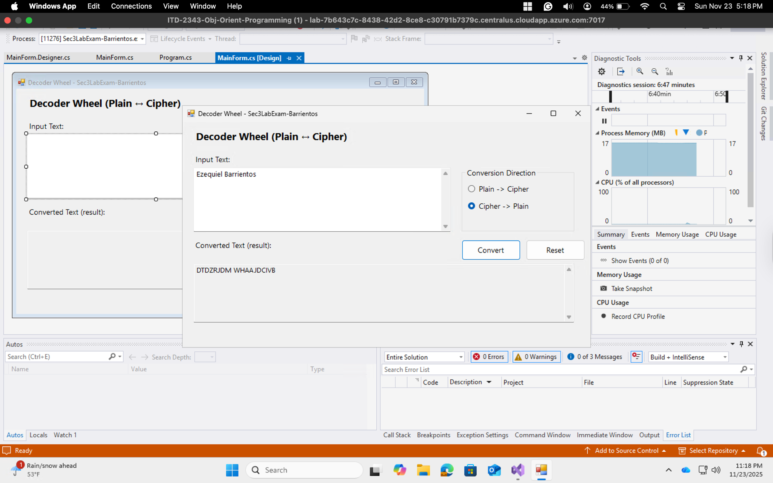

Test 5 HfVFo EIcN OFv oI MkX Cipher to Plain

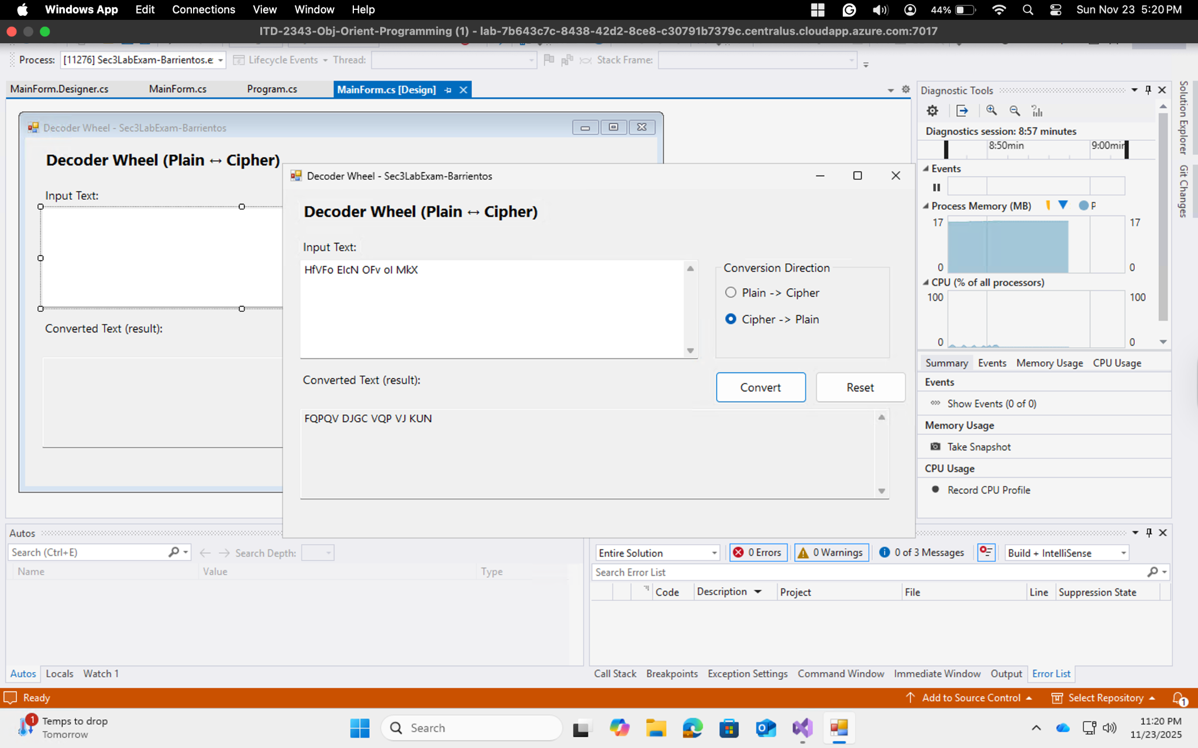

Test 6 Error

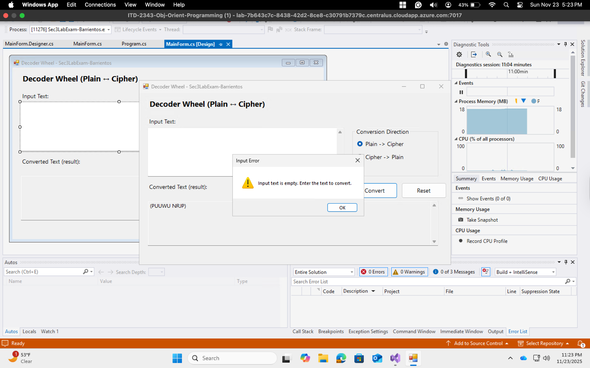

Test 7 Exit Message Count

